IdeationPhase
Define the Problem Statements
Date

Team ID

Project Name

Maximum Marks
3 Feb 2026

LTVIP2026TMIDS60231

ToyCraft Tales: Tableau's Vision into Toy Manufacturer Data

2 Marks

What is a Customer Problem Statement?
Instead of rushing into a solution, this template asks you to slow down and see the world through your customer’s eyes. You don’t start with what you want to build — you start with what they are struggling with.
This helps you uncover what really matters to them: their needs, frustrations, and emotions. Once you truly understand their problem, finding the right solution becomes much easier.

Why Use It?
It shows you what the customer actually needs. It builds empathy — you feel what they feel.
It guides your ideas and solutions in the right direction. It stops you from wasting time on the wrong things.
The Super Simple Format:
You just have to fill in the blanks like a story:
I am (who the customer is)
I’m trying to (what they want to do) But (what’s stopping them?) Because (why is this a problem?)
Which makes me feel (how do they feel?)
This turns a problem into a real situation, not just words. It’s like writing from their point of view so you can solve their problem, not just your idea of it.
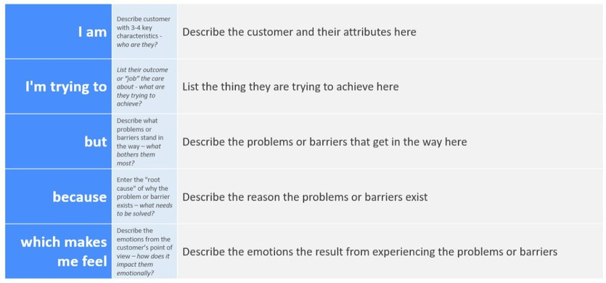

Example:
Problem Statement (PS)

PS-1

PS-2

PS-3
I am (Customer)

a teacher

a parent

an office employee
I’m trying to

my
students to enjoy the class.

find the best toys for my child

finish my work faster
But

they get bored

I don’t know which one are best

I waste time looking for files and data
Because

the lessons aren’t fun

stores don’t show what kids like most these days

everything is messy
Which makes me feel

sad and worried

confused and unsure what to buy

annoyed

